**Features**

**Onboarding (Quick Start)**

**Dashboard**

**Audit Center / Task**

**Compliance (Framework / Controls / Policies / Evidence/ Audit)**

**Risk Management**

**Automation (API Integrations / Test/ Automation etc)**

**Sample System Walkthrough – Watch Demo from 12 mins**

[cdn.embedly.com/widgets/media.html?src=https%3A%2F%2Fplayer.vimeo.com%2Fvideo%2F1027480289%3Fh%3D0476f32983%26app_id%3D122963&dntp=1&display_name=Vimeo&url=https%3A%2F%2Fvimeo.com%2F1027480289%2F0476f32983&image=https%3A%2F%2Fi.vimeocdn.com%2Fvideo%2F1947459476-9d10791cc381a56bf7da6e2b5fd2dc5cef4b0afc5af2e9605e265dac829b87a8-d_1280&key=96f1f04c5f4143bcb0f2e68c87d65feb&type=text%2Fhtml&schema=vimeo](https://cdn.embedly.com/widgets/media.html?src=https%3A%2F%2Fplayer.vimeo.com%2Fvideo%2F1027480289%3Fh%3D0476f32983%26app_id%3D122963&dntp=1&display_name=Vimeo&url=https%3A%2F%2Fvimeo.com%2F1027480289%2F0476f32983&image=https%3A%2F%2Fi.vimeocdn.com%2Fvideo%2F1947459476-9d10791cc381a56bf7da6e2b5fd2dc5cef4b0afc5af2e9605e265dac829b87a8-d_1280&key=96f1f04c5f4143bcb0f2e68c87d65feb&type=text%2Fhtml&schema=vimeo)

**Layout Samples**

**Dashboard**

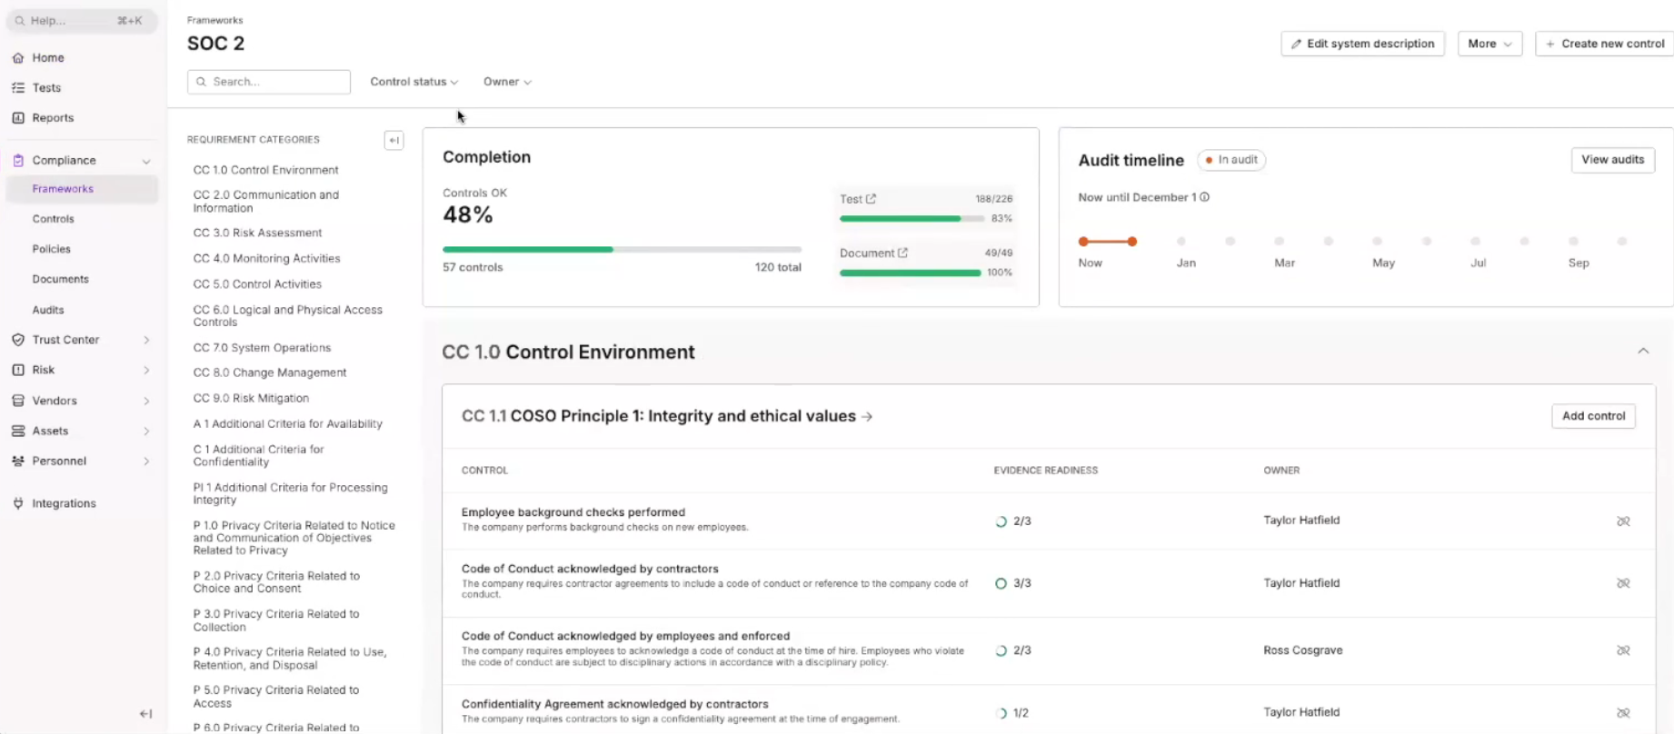

**Onboarding?**

Quick Start – attached details / info questions separately

**Frameworks**

ISO27001 , HIPPA, SOC 2, GDPR and Vendor Risk Management

Priority

* ISO27001
* SOC 2
* Vendor Risk Management

**Controls**

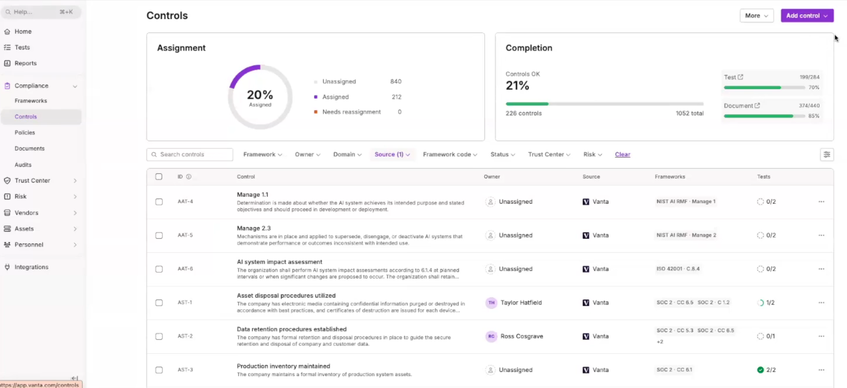

**Policies**

**Policy / Control Templates**

**Goal:** Start strong with vetted policies mapped to controls.

1. Library Curation
   * Provide versioned, legally reviewed templates (InfoSec, Access, BYOD, SDLC, BCP/DR, Incident, Vendor, Privacy).
2. Parameterization
   * Variables (company, roles, RTO/RPO, data classes); guided Q&A to tailor.
3. Cross-Mapping
   * Each clause maps to control IDs across frameworks (SOC 2, ISO, HIPAA, PCI, GDPR, ISO 42001).
4. Review & Approval
   * Redline workflow, legal/privacy review, e-sign, publication date & next review date.
5. Attestations & Training
   * Collect employee attestations; assign training modules; track completion.

**Automations:** Renewal reminders, change-impact analysis (which controls evidence needs updating when a policy changes).  
**Audit-Ready DoD:** All required policies approved, published, and attested; mappings visible; reviews current.

**Evidence tab**

**Evidence Collection & Documentation**

**Goal:** Gather, version, and prove controls with trustworthy artifacts.

1. Evidence Model
   * Define types (policy, log, screenshot, config export, code scan, attestation), retention, and freshness rules.
2. Evidence Requests
   * Per control, auto-create requests with examples & redaction tips; map to owners.
3. Integrations & Pulls
   * Connect cloud, CI/CD, ticketing, IdP, scanners; pull evidence on schedule.
4. Manual Uploads & Attestations
   * Drag-and-drop with guidance; templated attestations (e.g., quarterly access reviews).
5. Versioning & Chain of Custody
   * Immutable versions, timestamps, collector identity, hash; link evidence → control(s).
6. Quality Gates
   * Automated checks (date freshness, file type, redaction, control fit).
   * Human QA for narratives and diagrams.
7. System Description & Narratives
   * Generate/edit system description, data flows (DPIA where needed), policies, and SoA (ISO).
8. Auditor Package
   * One-click export by control, with evidence index and narratives.

**Automations:** Scheduled collectors, freshness alerts, “evidence completeness” meters, auto-indexing by control.  
**Audit-Ready DoD:** All required evidence present, fresh, QA-passed; system description and narratives finalized; export validated.

API Integrations

**Integrations**

**Goal:** Pull the right evidence & signals automatically.

1. System Discovery
   * Guided catalog: cloud accounts, IdP, code repos, ticketing, SIEM, EDR, HRIS, MDM, vulnerability scanners.
2. Connector Setup
   * OAuth/service accounts; least-privilege scopes; secrets in vault.
3. Data Mapping
   * Normalize into a common schema (assets, users, configs, events, findings).
4. Sync Policies
   * Set frequencies, backfill windows, retention, masking rules.
5. Health & DQ
   * Connector health dashboard, retries, lag alerts, sample-based validation.
6. Sandbox→Prod
   * Test connectors before production; change control for scopes/permissions.

**Automations:** Auto-suggest connectors based on selected controls; connector-health alerts.  
**Audit-Ready DoD:** All mandatory connectors healthy; data freshness within SLA; least-privilege reviewed.

Audit Centre



